**BASICS OF LOGIC GATES**

· **AND gate**

· **OR gate**

· **NOT gate**

· Show the output using **LEDs**

## ****AND Gate — Series Connection:****

In an AND gate, output is HIGH (1) **only when both inputs are HIGH**.

+5V

│

SW1

│

SW2

│

└─────► LED ──► GND

### Explanation:

Both SW1 and SW2 must be **closed (ON)** to complete the path.

LED glows **only when both are pressed** → behaves like **AND gate**.

## ****OR Gate — Parallel Connection:****

In an OR gate, output is HIGH (1) **if any one input is HIGH**.

+5V

│

┌───┴────┐

│ │

SW1 SW2

│ │

└──┬─────┘

│

LED

│

GND

### Explanation:

LED glows if **either SW1 or SW2 is pressed**.

This mimics **OR gate** behavior.

## ****NOT Gate — Inverter Using Switch and Transistor/IC****

A NOT gate outputs **opposite** of input:

Input HIGH → Output LOW

Input LOW → Output HIGH

We can't do this with switches alone, but we can simulate it using:

**IC 7404** (NOT gate)

Or a simple **pull-up + switch to GND** trick

+5V ───┬────────────┐

│ │

[10K] SW

│ │

OUT GND

│

LED

│

GND

### Explanation:

When **SW is open**, resistor pulls OUT HIGH → LED ON

When **SW is pressed**, OUT goes to GND → LED OFF

This mimics a **NOT gate**

| **Logic Gate** | **Connection Type** | **LED Behavior** |
| --- | --- | --- |
| AND | Series | ON only if both switches are ON |
| OR | Parallel | ON if any switch is ON |
| NOT | Pull-up + switch | ON when switch is **not** pressed |

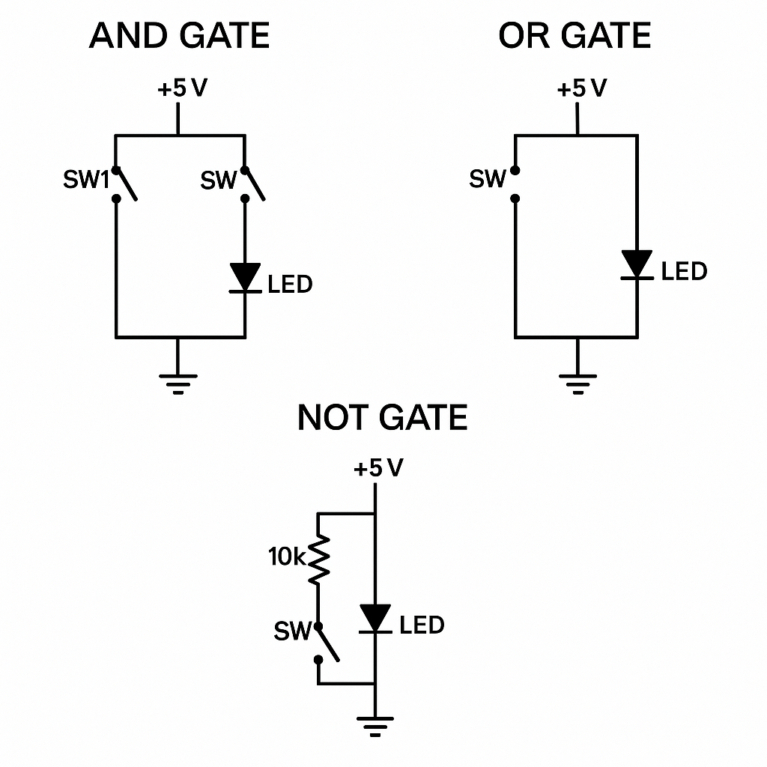

### ****Goal:****

**NAND**

**NOR**

**XOR**

**XNOR**

Control two lights (LEDs) to **blink** (turn ON/OFF) based on the combination of two **switch inputs** using **logic gates** (NAND, NOR, XOR, XNOR).

2 switches: SW1 and SW2

2 LEDs: LED1, LED2

Logic gates: NAND, NOR, XOR, XNOR

| **SW1** | **SW2** | **NAND** | **NOR** | **XOR** | **XNOR** |
| --- | --- | --- | --- | --- | --- |
| 0 | 0 | 1 | 1 | 0 | 1 |
| 0 | 1 | 1 | 0 | 1 | 0 |
| 1 | 0 | 1 | 0 | 1 | 0 |
| 1 | 1 | 0 | 0 | 0 | 1 |

### ****Simple LED Blink Logic (Example Ideas):****

#### ****Using XOR Gate:****

Connect SW1 and SW2 to XOR gate input

Output → LED1

Behavior: LED1 will **blink (ON)** when **only one switch is ON**

#### ****Using XNOR Gate:****

Same setup, Output → LED2

Behavior: LED2 will be ON when **both switches are the same** (00 or 11)

### ****Wiring Suggestion (Practical Breadboard Setup):****

SW1, SW2 → Inputs to all gates (NAND/NOR/XOR/XNOR)

XOR → LED1

XNOR → LED2

Add resistors in series with LEDs

**SERIES AND PARALLEL CONNECTION**

### ****Series Connection:****

Components are connected one after another.

**Same current** flows through all.

If one component fails → entire circuit breaks.

+V ─── SW1 ─── SW2 ─── LED ─── GND

· Both switches must be ON (closed) for LED to glow.

· Acts like an **AND** gate.

### ****Parallel Connection:****

Components share the same voltage across them.

Current divides.

If one path breaks, others still work.

┌── SW1 ──┐

+V ───────┤ ├── LED ─── GND

└── SW2 ──┘

· If **any switch is ON**, LED glows.

· Acts like an **OR** gate.

SW1 ─┬────> A (gate)

└────> A' (other gate)

SW2 ─┬────> B (gate)

└────> B' (other gate)

XOR(A, B) ──> LED1

XNOR(A', B') ──> LED2

| **Connection** | **Used For** | **Behavior** |
| --- | --- | --- |
| Series | AND-like logic | All switches ON to pass current |
| Parallel | OR-like logic | Any switch ON to pass current |
| Gate Inputs | Series or Parallel | Depends on logic needed |
| Gate Outputs | Connected to separate LEDs | Each LED shows a logic condition |

## Real Setup Using XOR and XNOR

Let’s build this idea:

### Inputs:

SW1, SW2 — switches for input

Each connected to logic gate inputs

### Logic:

XOR(SW1, SW2) → LED1